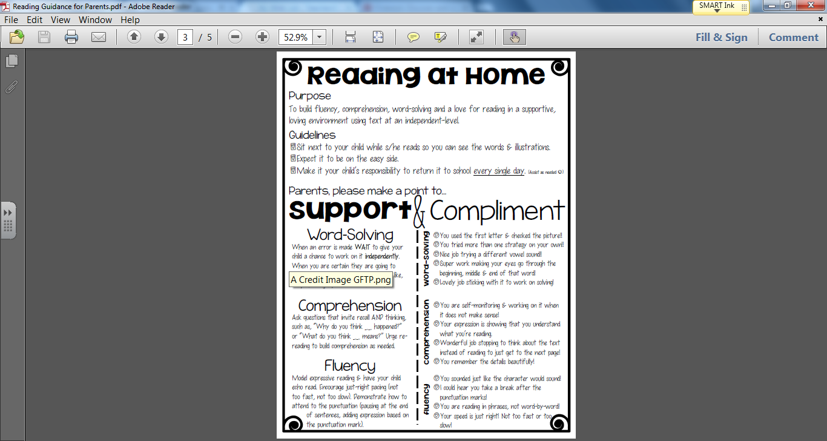

*keep going, stop them saying something like “Try that again,” or “Make it match.”*