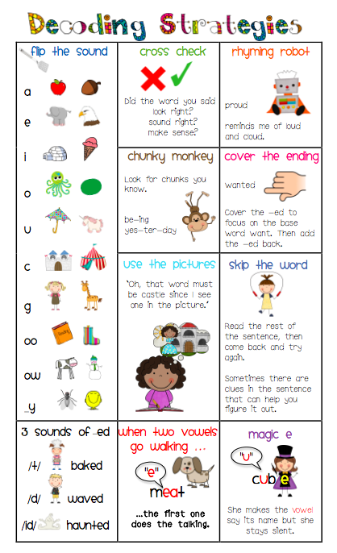

**Stretchy Snake:**

-slowly stretch out each sound in the word (segmenting)

-say them faster until they are blending the sounds together to form the word

[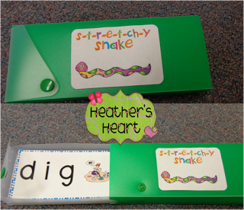](http://4.bp.blogspot.com/-2BhgPpMqhW8/UHNyThnFU_I/AAAAAAAAB48/T8T83KKRl_s/s1600/stretchy+snake+boxes.png)

**Go to the site below for the cards to use in this activity:**

<https://docs.google.com/file/d/0B2X5kKkqbEP-c096S0hDUkoyazQ/edit?pli=1>